**Project Name: *GATED COMMUNITY ERM***

**Project Member:**

**Aditya Abu** 210543181**002**

**Vaishnavi Thorat** 210543181**11**6

**Shraddha Sabne** 210543181**1**04

**Rina Borchate** 2105431810**78**

**Abstract:**

* In Conventional housing society management system, all society works are done manually. Society chairman have to keep all the society expenses report on paper file. At some time if this data is needed, then retrieving this data is very slow and tiresome work.
* This problem needs to be solved so that members can come to know what is happening in society. Generating bill and sending it to each society member is also a tiresome work. Sometime members did not get bills and chances of being lost. Payment collection is also big task in society.
* So, the system is needed to overcome these problems and reduce human efforts.

**Implementation Technologies:**

**Technologies used:**

1. Spring Framework
2. Html
3. Css
4. Bootstrap
5. MySql
6. Hibernate
7. ReactJs
8. **Spring Framework:**

Spring Framework is a Java platform that provides comprehensive infrastructure support for developing Java applications. Spring handles the infrastructure so you can focus on your application.

Spring enables you to build applications from “plain old Java objects” (POJOs) and to apply enterprise services non-invasively to POJOs. This capability applies to the Java SE programming model and to full and partial Java EE.

**1.1 Features of Spring Framework:**

**1. Lightweight**

Spring is modular lightweight framework which allows you to selectively use any of its modules on the top of Spring Core.

**2. Inversion of Control (IOC)**

This is another top feature of Spring framework where application dependencies are satisfied by the framework itself. Framework creates the object in runtime and satisfies application dependencies.

**3. Aspect Oriented Programming (AOP)**

Aspect Oriented Programming (AOP) is very popular in programming world and in Spring it is well implemented. Developer can use Aspect Oriented Programming (AOP feature of Spring to develop application in which business logic is separated from system services.

**4. Container**

Spring provides their own container for managing the bean lifecycle.

**5. MVC Framework**

Spring MVC Framework is used for developing MVC based web applications.

**6. Transaction Management**

Spring framework provides generic Transaction Management layer which can be used with or without J2EE(JEE) environment.

**7. JDBC Exception Handling**

Spring provides their own abstraction of JDBC exception which further simplifies the exception handling in program.

**1.2 Advantages of Spring Framework:**

**1. Solving difficulties of Enterprise application development**

Spring is solving the difficulties of development of complex applications, it provides Spring Core, Spring IoC and Spring AOP for integrating various components of business applications.

**2. Support Enterprise application development through POJOs**

Spring supports development of Enterprise application development using the POJO classes which removes the need of importing heavy Enterprise container during development. This makes application testing much easier.

**3. Easy integration other frameworks**

Spring designed to be used with all other frameworks of Java, you can use ORM, Struts, Hibernate and other frameworks of Java together. Spring framework do not impose any restriction on the frameworks to be used together.

**4. Application Testing**

Spring Container can be used to develop and run test cases outside enterprise container which makes testing much easier.

**5. Modularity**

Spring framework is modular framework and it comes with many modules such as Spring MVC, Spring ORM, Spring JDBC, Spring Transactions etc. which can used as per application requirement in modular fashion.

**6. Spring Transaction Management**

Spring Transaction Management interface is very flexible it can configure to use local transactions in small application which can be scaled to JTA for global transactions.

1. **The JDBC Template**

The central class of the Spring JDBC abstraction framework is the **JdbcTemplate** class that includes the most common logic in using the JDBC API to access data, such as handling the creation of connection, statement creation, statement execution, and release of resource. The **Jdbc-Template**class can be found in the **org. springframework.jdbc.core**package.

The **JdbcTemplate** class instances are thread-safe once configured. A single **JdbcTemplate** can be configured and injected into multiple DAOs.

We can use the **JdbcTemplate** to execute the different types of SQL statements. **Data Manipulation Language** (**DML**) is used for inserting, retrieving, updating, and deleting the data in the database such as **SELECT**, **INSERT**, or **UPDATE** statements

**2.1** **MySQL**

MySQL, the most popular Open Source SQL database management system, is developed, distributed, and supported by Oracle Corporation .

**Features of MySQL:**

* **MySQL is a database management system.**

A database is a structured collection of data. It may be anything from a simple shopping list to a picture gallery or the vast amounts of information in a corporate network. To add, access, and process data stored in a computer database, you need a database management system such as MySQL Server. Since computers are very good at handling large amounts of data, database management systems play a central role in computing, as standalone utilities, or as parts of other applications.

* **MySQL databases are relational.**

A relational database stores data in separate tables rather than putting all the data in one big storeroom. The database structures are organized into physical files optimized for speed. The logical model, with objects such as databases, tables, views, rows, and columns, offers a flexible programming environment.

* **MySQL software is Open Source.**

Open Source means that it is possible for anyone to use and modify the software. Anybody can download the MySQL software from the Internet and use it without paying anything.

* **The MySQL Database Server is very fast, reliable, scalable, and easy to use.**

MySQL Server was originally developed to handle large databases much faster than existing solutions and has been successfully used in highly demanding production environments for several years. Although under constant development, MySQL Server today offers a rich and useful set of functions. Its connectivity, speed, and security make MySQL Server highly suited for accessing databases on the Internet.

* **MySQL Server works in client/server or embedded systems.**

The MySQL Database Software is a client/server system that consists of a multithreaded SQL server that supports different back ends, several different client programs and libraries, administrative tools, and a wide range of application programming interfaces (APIs).

1. **Hibernate**
2. Hibernate is an object–relational mapping tool for the Java programming language.
3. It provides a framework for mapping an object-oriented domain model to a relational database.
4. Hibernate handles object–relational impedance mismatch problems by replacing direct, persistent database accesses with high-level object handling functions.
5. **ReactJs**
6. React (also known as React.js or ReactJS) is a free and open-source front-end JavaScript library for building user interfaces or UI components. It is maintained by Facebook and a community of individual developers and companies.
7. React can be used as a base in the development of single-page or mobile applications.
8. **Hardware and Software Requirements (Minimum):**

**Hardware:**

1. Intel i3 processor 3rd generation or later / AMD Ryzen 200 2nd generation or later

2. 2 GB ddr3 ram.

3. Windows 7 or newer Home edition or later.

4. 200 GB Sata HDD Space

5. Data Connection 200 kbps

**Software:**

1. Eclipse 4.7 Oxygen
2. MySQL 5.7 with Workbench 8.0
3. Google Chrome version 79.0
4. Apache Tomcat Server 8.5
5. Maven Dependencies
6. **UML Diagrams:**

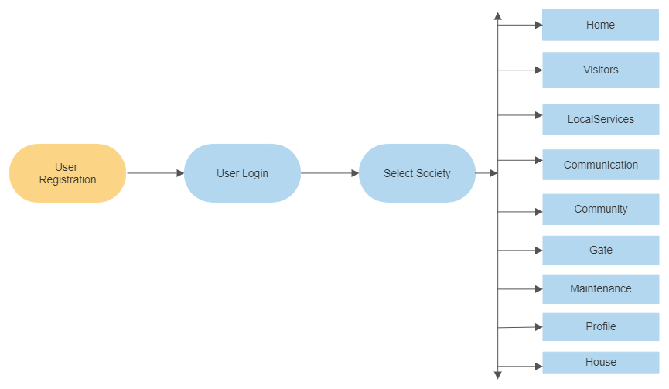

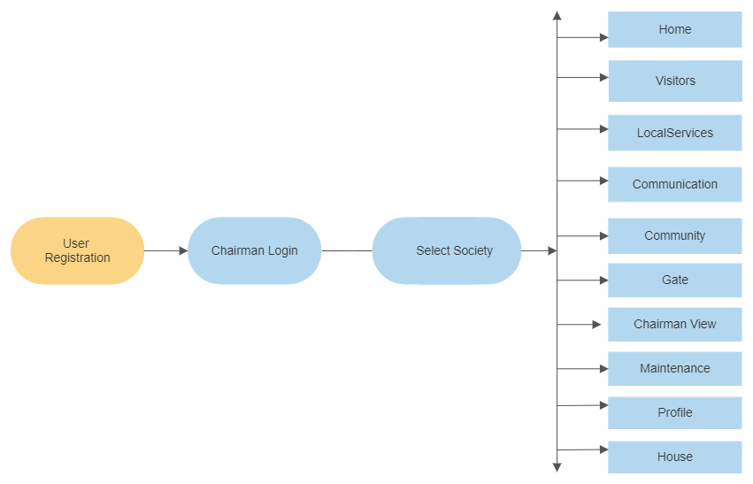

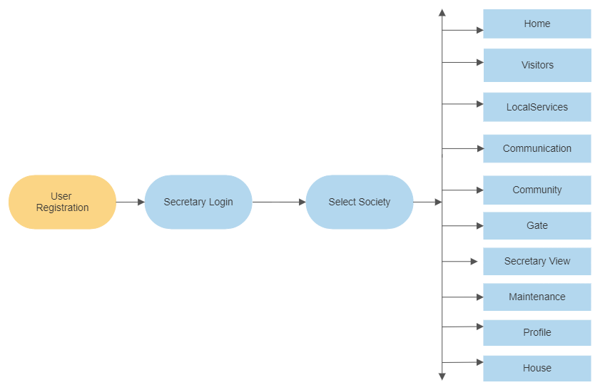

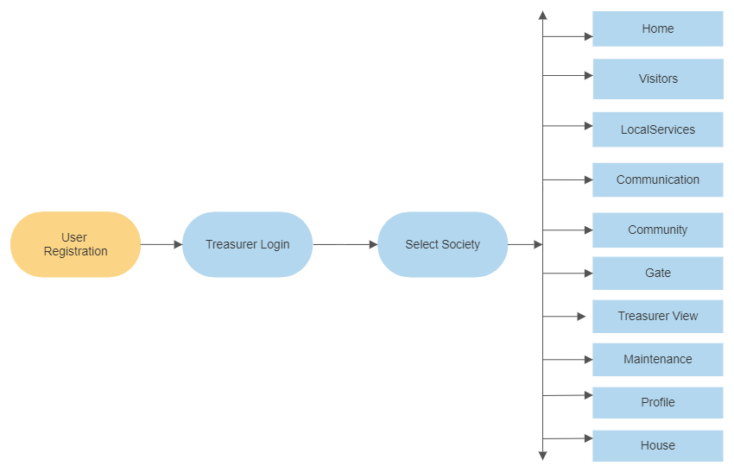

1. **End to End Flow of Application:**

**User:**

* 1. User will login to the portal or will have to register if he is not a registered user.
  2. After registration User will login and Default page will be displayed to him which will display Home page.
  3. On the header side there are many tabs like Visitors, Local Services, Communication, Community, Gate, Profile and House.
  4. From that page User can click on the ‘**Visitor’** tab and reach the visitor details page. On that page user will get the information of visitors who will visited to user home.
  5. When User click on the ‘**Local Services’** tab and He/She will reach to the local services details page. On that page user will get the information of local services.
  6. When User click on the **‘Communication’** tab and He/She will reach to the communication details page. On that page user user can interact with other residents of society.
  7. When User click on the **‘Community’** tab and He/She will reach to the community details page. On that page user will get the information of Emergency Contacts, Management, Residents.
  8. When User click on the **‘Gate’** tab and He/She will reach to the gate details page. On that page user will get the information of gate details.
  9. When User click on the **‘Maintenance’** tab and He/She will reach to the maintenance details page. On that page user will get the information of maintenance charges details.
  10. When User click on the **‘Profile’** tab and He/She will reach to the profile details page. On that page user will get the information of He/She profile in that all the details of house.
  11. When User click on the ‘**House’** tab and He/She will get the house details. In that user will choose their flat number and wing. This is applicable for only if users have number of society and houses.

**Chairman:**

* 1. **Chairman** will login to the portal or will have to register if he is not a registered user.
  2. After registration Chairman will login and Default page will be displayed to him which will display home page.
  3. On the header side there are many tabs like Visitors, Local Services, Communication, Community, Gate, Maintenance, Chairman View, Profile and House.
  4. From that page Chairman can click on the ‘**Visitor’** tab and reach the visitor details page. On that page chairman will get the information of visitors who will visited to chairman home.
  5. When Chairman click on the ‘**Local Services’** tab and He/She will reach to the local services details page. On that page chairman will get the information of local services.
  6. When Chairman click on the **‘Communication’** tab and He/She will reach to the communication details page. On that page chairman can interact with other residents of society.
  7. When Chairman click on the **‘Community’** tab and He/She will reach to the community details page. On that page chairman will get the information of Emergency Contacts, Management, Residents.
  8. When Chairman click on the **‘Gate’** tab and He/She will reach to the gate details page. On that page chairman will get the information of gate details.
  9. When Chairman click on the **‘Chairman View’** tab and He/She will reach to the chairman view details page. On that page chairman will get the information of all the residents of society, all notices of society and he have rights to send the notices.
  10. When Chairman click on the **‘Maintenance’** tab and He/She will reach to the maintenance details page. On that page chairman will get the information of maintenance charges details.
  11. When Chairman click on the **‘Profile’** tab and He/She will reach to the profile details page. On that page chairman will get the information of He/She profile in that all the details of house.
  12. When Chairman click on the ‘**House’** tab and He/She will get the house details. In that chairman will choose their flat number and wing. This is applicable for only if users have number of society and houses.

**Secretary:**

* 1. Secretary will login to the portal or will have to register if he is not a registered user.
  2. After registration Secretary will login and Default page will be displayed to him which will display home page.
  3. On the header side there are many tabs like Visitors, Local Services, Communication, Community, Gate, Profile and House.
  4. From that page Secretary can click on the ‘**Visitor’** tab and reach the visitor details page. On that page secretary will get the information of visitors who will visited to user home.
  5. When Secretary click on the ‘**Local Services’** tab and He/She will reach to the local services details page. On that page secretary will get the information of local services.
  6. When Secretary click on the **‘Communication’** tab and He/She will reach to the communication details page. On that page secretary can interact with other residents of society.
  7. When Secretary click on the **‘Community’** tab and He/She will reach to the community details page. On that page secretary will get the information of Emergency Contacts, Management, Residents.
  8. When Secretary click on the **‘Gate’** tab and He/She will reach to the gate details page. On that page secretary will get the information of gate details.
  9. When Secretary click on the **‘Secretary View’** tab and He/She will reach to the secretary view details page. On that page secretary will get the information of all the local services of society, all visitors of society and he have rights to add and delete the local services.
  10. When Secretary click on the **‘Maintenance’** tab and He/She will reach to the maintenance details page. On that page secretary will get the information of maintenance charges details.
  11. When Secretary click on the **‘Profile’** tab and He/She will reach to the profile details page. On that page secretary will get the information of He/She profile in that all the details of house.
  12. When Secretary click on the ‘**House’** tab and He/She will get the house details. In that secretary will choose their flat number and wing. This is applicable for only if users have number of society and houses.

**Treasurer:**

* 1. Treasurer will login to the portal or will have to register if he is not a registered user.
  2. After registration User will login and Default page will be displayed to him which will display home page.
  3. On the header side there are many tabs like Visitors, Local Services, Communication, Community, Gate, Profile and House.
  4. From that page Treasurer can click on the ‘**Visitor’** tab and reach the visitor details page. On that page treasurer will get the information of visitors who will visited to user home.
  5. When Treasurer click on the ‘**Local Services’** tab and He/She will reach to the local services details page. On that page treasurer will get the information of local services.
  6. When Treasurer click on the **‘Communication’** tab and He/She will reach to the communication details page. On that page treasurer can interact with other residents of society.
  7. When Treasurer click on the **‘Community’** tab and He/She will reach to the community details page. On that page treasurer will get the information of Emergency Contacts, Management, Residents.
  8. When Treasurer click on the **‘Gate’** tab and He/She will reach to the gate details page. On that page treasurer will get the information of gate details.
  9. When Treasurer click on the **‘Treasurer View’** tab and He/She will reach to the treasurer view details page. On that page treasurer will get the information of all the maintenance of society for all the users.
  10. When Treasurer click on the **‘Maintenance’** tab and He/She will reach to the maintenance details page. On that page treasurer will get the information of maintenance charges details.
  11. When Treasurer click on the **‘Profile’** tab and He/She will reach to the profile details page. On that page treasurer will get the information of He/She profile in that all the details of house.
  12. When Treasurer click on the ‘**House’** tab and He/She will get the house details. In that treasurer will choose their flat number and wing. This is applicable for only if users have number of society and houses.

1. **Future Scope of Project**
2. This project can be enhanced further by adding club house booking, online voting system, online payment facility for the members to reduce the extra work of the admin. The software is flexible enough to be modified and implemented as per future requirements.
3. Message and Email alerts for various happenings in the society can be added to the system so that users do not miss the updates and happenings of the society
4. This project can be enhanced further by Developing a Mobile App. Also, we can Develop a Full-Fledged accounting module.

**Thank You!**